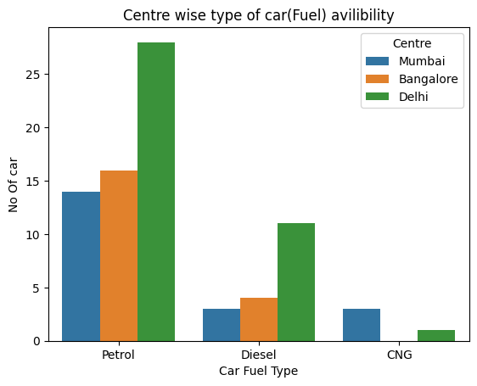

**📊 Interpretation & insights**

* **Petrol cars dominate** in all centres, but especially in Delhi: Delhi has ~28 petrol cars, which is substantially higher than Mumbai and Bangalore.
* **Diesel availability is modest** and again highest in Delhi (~11) compared to Bangalore (~4) and Mumbai (~3).
* **CNG availability is very low** in Bangalore (essentially none), very low in Delhi (~1) and low in Mumbai (~3).
* So: Delhi is the most diverse and abundant in terms of fuel-type availability (especially for petrol and diesel). Mumbai and Bangalore are much lower overall, and Bangalore in particular seems to have almost no CNG-cars available.

**🔍 Possible implications**

* If you are sourcing cars of a particular fuel type and centre, Delhi may offer better choice, particularly for petrol and diesel.
* If you are looking for CNG-fuel type, you might struggle in Bangalore (virtually none) and need to look at Mumbai or Delhi.
* The dominance of petrol across all centres suggests petrol cars are the primary category available in this context; diesel and CNG remain niche.

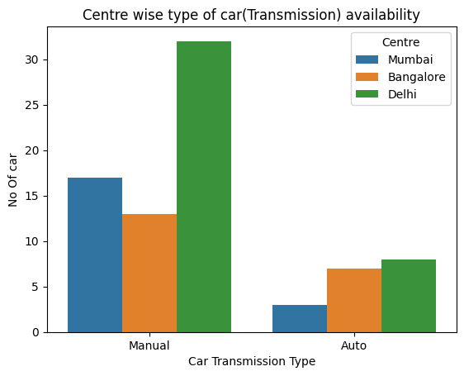

The bar chart titled **"Centre wise type of car (Transmission) availability"** compares the number of **Manual** and **Automatic** transmission cars available in **Mumbai**, **Bangalore**, and **Delhi**. Here's the key insights:

**🔧 Manual Transmission Cars**

* **Delhi** has the highest availability with **~32 cars**.
* **Mumbai** follows with **~18 cars**.
* **Bangalore** has the least with **~13 cars**.

**⚙️ Automatic Transmission Cars**

* **Delhi** again leads with **~9 cars**.
* **Bangalore** has **~7 cars**.
* **Mumbai** has the fewest with **~3 cars**.

**📊 Key Insights**

* **Manual cars are more prevalent** than automatic ones in all three centres.
* **Delhi** has the **highest overall availability** for both types.
* **Mumbai** has the **lowest number of automatic cars**, indicating a possible preference or lower demand/supply.

Would you like help drawing conclusions from this data for a report or presentation?

3.

Corelation coefficient between Kilometres Driven & Car price is -0.175343652982732, which is very week negative relation. Means that car price & Kilometres Driven are inversely related. However, their strength of relation is very week. Plausible cause for this week association might be the below reason:

* 1. Price for Deli is missing, which restrict the proper calculation of the association.
  2. There might be other variables exists which have higher corelation with price.

4.

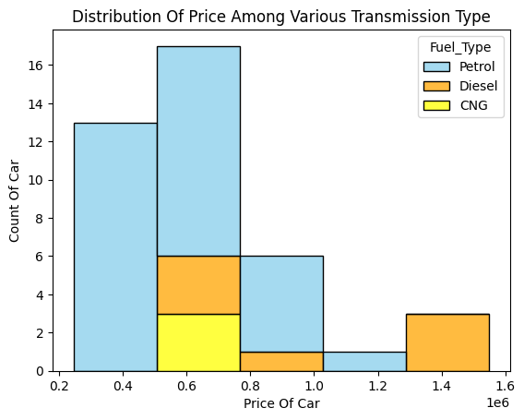

Here's a detailed analysis of the bar chart titled **"Distribution Of Price Among Various Transmission Type"**:

**📊 Chart Overview**

* **X-axis**: Car price (in Lakh, from 2 to 16).
* **Y-axis**: Count of cars.
* **Fuel Types**:
  + **Petrol**: Blue bars
  + **Diesel**: Orange bars
  + **CNG**: Yellow bars

**🔍 Key Insights**

**1. Price Range Concentration**

* **Majority of cars** fall within the **2 to 8 Lakh** price range.
* This suggests that the market is skewed towards **affordable vehicles**.

**2. Fuel Type Distribution**

* **Petrol Cars**:
  + Most abundant in the **lower price range** (2 to 8 lakh).
  + Indicates petrol cars are generally **more budget-friendly**.
* **Diesel Cars**:
  + Spread across **all price ranges**, including higher-end (up to 14 Lakh).
  + Diesel cars show **greater price diversity**, possibly due to larger vehicle types or premium models.
* **CNG Cars**:
  + Least represented overall.
  + Mostly found in the **mid-range** (4 to 8 lakh).
  + Suggests **limited availability** or **niche market** for CNG vehicles.